OFFICIAL COORDINATION REQUEST FOR
NON-ROUTINE OPERATIONS AND MAINTENANCE

COORDINATION TITLE- 25BON004 Update MOC Bradford Island Exit Hydro Survey
COORDINATION DATE- 4 February 2025
PROJECT- BON
RESPONSE DATE- 13 February 2025

Description of the problem
UPDATE 12 February 2025: The hydro survey planned for Thursday, 13 February 2025, has been postponed to Tuesday, 18 February 2025 due to forecasted weather causing safety concerns with boat operations on the 13th. Additional scope to hydro survey has been added to include a hydro survey of the Powerhouse 1 Main Unit intake area for trash accumulation in preparation for upcoming work. This additional scope does not impact the previously reported outage timeframe presented in this MOC.

In support of dredging around the Bradford Island (BI) fishway exit, the dredging PDT requires a hydro survey of the area to be conducted on 13 18 February 2025. This operation will result in a closure of the Ice and Trash Sluiceway (ITS) and boat disturbance near the exit and altered flow conditions in the Bradford Island fishway for up to 2 hours. The survey requires FV3-7 and FV3-9 be mostly closed for the duration of the work, this will cause water levels in the BI ladder and entrance differentials to drop below FPP criteria during this period. The 18 February date was selected due to the only alternative date to conduct the hydro survey being during the first week of March. To minimize passage delays and impacts to migrating ESA-listed species and to comply with the in-water work period (IWWP) outlined in the 2024 FPP Section 2.4.1 Adult Fish Facilities-Winter Maintenance Period (December 1-end of February) the February survey date was preferred. The Hydro survey is scheduled to be conducted at 0900 following isolation of hazardous energy points and is expected to take two hours to complete. The total hydro survey work period will be six hours or less when accounting for the time allotted to follow Hazardous Energy Control Procedures. The added scope of the B1 Main Unit intake trash accumulation inspection will not add any additional outage timeframe than what is already presented here in the MOC.

Type of outage required

Impact on facility operation Reduced flow of FV 3-7, 3-9; ITS closure

Impact on unit priority None

Impact on forebay/tailwater operation None. Impacts to BI ladder head and entrance differentials for approximately 2 hours.

Impact on spill None

Dates of impacts/repairs 13 February 2025 update: 18 February 2025.

Length of time for repairs 6 hours or less

Analysis of potential impacts to fish

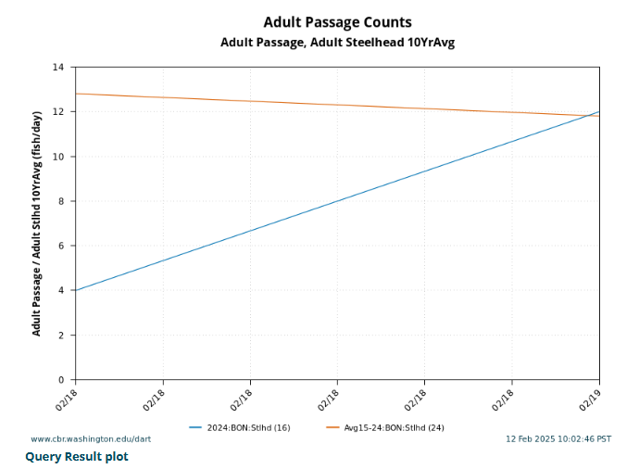
Figure 1: Steelhead Combined Daily Passage Numbers for Work Period (2/18) for 2024 Passage Year Compared to the 10 Year Average (2015-2024) for Work Period. Figure obtained from Columbia River DART at www.cbr.washington.edu/dart.
- 10-year average passage by run during the period of impact for adults and juvenile listed species, as appropriate for the proposed action and time of the year;

Table 1: 10-Year averages and Percent of Run Affected during 02/18 work period. Numbers queried from Columbia River DART (2025).
Date | 02/18 10-year avg | 10 Year avg total run | Percent Run Affected
Chinook | 0 | 690,922 | 0
Steelhead | 14 | 151,205 | 0.009 %
Lamprey | 0 | 41,426 | 0%

- Statement about the current year’s run (e.g., higher or lower than 10-year average)
- Total Chinook: The 2024 run of all Chinook runs combined at the year to date (YTD) of this MOC is 648902, which is less than the 2015-2024 ten-year average combined of 690,922. However, this is with the caveat that the current year’s (2025) counts have yet to occur.
- Steelhead: The 2024 run of Steelhead at the YTD of this MOC is 181,907, which is higher than the 2015-2024 ten-year average of 151,205.
- Estimated exposure to impact by species and age class (i.e., number or percentage of run exposed to an impact by the action);
- Type of impact by species and age class (increased delay, exposure to predation, exposure to a route of higher injury/mortality rate, exposure to higher TDG, etc.);
Adults that are passing through the BI ladder may be delayed during the period that Fish Valves 3-7 and 3-9 are mostly closed and flows are reduced, including attraction flow from entrance head differentials, leading to holding in pools between weirs or escapement back to tailwater where potential increased exposure to pinniped predation is possible.
The ITS closure may impact out-migrating Steelhead kelts and juvenile Salmonids and Pacific Lamprey during the outage period. However, due to historically low numbers in both adult and juvenile passage during this work period, impacts to fish passage are expected to be minimal.

Summary statement - expected impacts on:

Downstream migrants: minimal as we do not foresee needing to have the ITS closed for longer than the allowable closure time stated in the FPP during winter maintenance season.

Upstream migrants (including Bull Trout) Any fish passing upstream through the BI ladder while flow is reduced will be at least slowed down as the ladder is out of compliance with the FPP for the duration of the survey Reduced fishway entrance differential at the Bradford Island Fishway can reduce fish attraction to the entrance, leaving fish susceptible to predation in the PH1 tailrace. However, there have been no sea lions observed within the PH1 tailrace according to the Fisheries Field Unit (FFU) point count surveys. This work is scheduled during the IWWP while fish numbers remain low to reduce predation, and passage impacts on upstream migrating fish.

Lamprey minimal.

Comments from agencies

From: Trevor Conder - NOAA Federal <trevor.conder@noaa.gov>
Sent: Tuesday, February 11, 2025 8:32 AM
To: Madson, Patricia L CIV USARMY CENWP (USA) <Patricia.L.Madson@usace.army.mil>
Subject: [Non-DoD Source] Re: FPOM Official Coordination: 25BON004 MOC Bradford Island Exit Hydro Survey

NOAA supports

From: Tom Lorz <lort@critfc.org>
Sent: Thursday, February 13, 2025 9:45 AM
To: Madson, Patricia L CIV USARMY CENWP (USA) <Patricia.L.Madson@usace.army.mil>
Subject: [Non-DoD Source] Re: FPOM Official Coordination: 25BON004 Update MOC Bradford Island Exit Hydro Survey

That will be fine

Final coordination results – Work will proceed as coordinated.

Please email or call with questions or concerns.
Thank you,

Jase Owens
Bonneville Project Fisheries
Jaselyn.A.Owens@usace.army.mil

And

Patricia Madson
NWP Operations Division Fishery Section
Columbia River Coordination Biologist
Patricia.L.Madson@usace.army.mil

